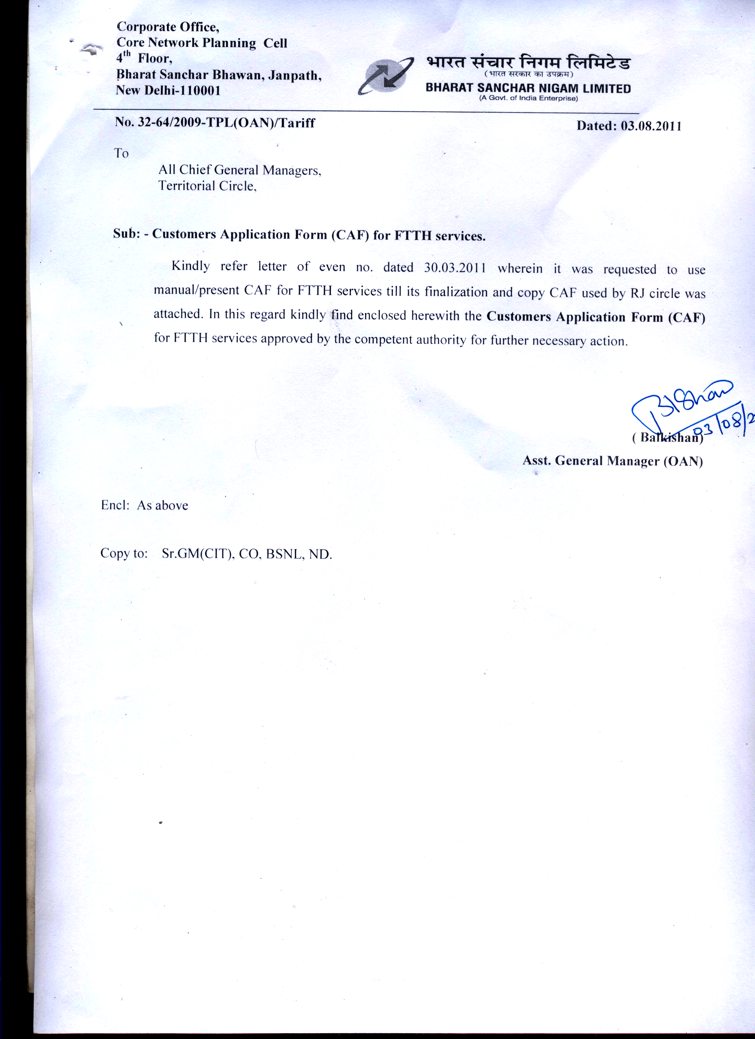

 | BHARAT SANCHAR NIGAM LIMITED  (website address)  FORM FOR FIBER BASED SERVICES NEW CONNECTION |  |  |  |  | Affix self signed passport size photograph (required for FTTH facility only)
Companies/ Organizations |  |  | Individuals
(tick appropriate box)

(Please read the instructions before filling the form)
Whether Existing Customer of BSNL Yes No if Yes provide the Account Number _____________________________________________
- A. Title/ Name of the Customer/ Company/ Firm/ Organization (SURNAME FIRST):-

___________________________ ________________________ ___________________________________
B. Name of the Joint Applicant, if any :-
_____________________________________________________________________
- Name of Father/ Husband/ Group/ Proprietor/ Partner(s)

___________________________ ________________________ ___________________________________
3. Nominee Name:- _____________________________________ 4.PAN/GIR No:
5. Contact Number , if any: Home: _________________________ Business ___________________ Mobile_______________
6. Complete Address where service(s) is/ are required:
House No Street/ Road/ Village
______________________ ___________________________________________________
Bldg./Appt.
___________________________________________________________________________________________
Area/ Locality/ Tehsil
_________________________________________________________________________________
City/ District Pin
_____________________________________________________________________________________________________________________________ ______________________________

7. Billing/ Correspondence Address (if different from 5 above)

_______________________________________________________________________________________________________________________________________________________________________________
______________________________________________________________________________________________________________________________________________Pin
8. E-mail address (if any): _______________________@______________________
9. Gender :- Male Female 10. Date of Birth:-

11. Wheather the applicant is a retired or working Employee of Govt./PSU/CPSU/ Yes No
12. Purpose: Residence Business Govt. PSU
13. Service Type:- Broadband IPTV/CABLE TV Telephone VIDEO
14. Number of Connections Required:- Broadband ---- IPTV ---- Telephone -----
15.a Facilities Required on Telephones (tick whichever is required) (please affix photograph for ISD facility) :
STD ISD CLI Hotline Conferencing Call Forwarding Hunting facility Abbreviated dialing
15 b Facilities Required on Video (tick whichever is required) (please affix photograph for ISD facility) :
Video conferencing Video Calls Others
16. Whether Telephone instrument is required: Yes No 17. Whether STB is required: Yes No
18. Type of ONT Type-A Type-B
19. a Mention the tariff package required for Broadband IPTV Telephone
[Please see various tariff packages available] _______________ ____________ _________________
19 .b. Bill frequency Monthly Yearly Five Yearly
19 c Bundled Service Packages __________

20. Payment Mode: Cash Demand Draft Amount

Payment Details: DD No. Dated

Drawn On: Bank Branch

I hereby declare that information given above is true to the best of my knowledge and I will abide by the prevailing Telegraph Act/ Rules framed thereunder & Tariffs as amended from time to time. I am not a defaulter on account of non-payment of bills for any telecom services provided by any service provider. In the event of any dispute concerning any telecom line, apparatus or appliance, bill etc., between me/us and BSNL, the matter will be referred to the sole Arbitrator, appointed by a nominated authority in BSNL and shall be governed by the provisions of the Arbitration and Conciliation Act, 1996.

Signature of Customer/ Authorized Signatory Signature of Customer/ Authorized Signatory
Signed on: Date

CUSTOMERS APPLICATION FORM

- TERMS & CONDITIONS
- Booking will be confirmed subject to feasibility.
- BSNL shall have the sole discretion to accept or reject the application without assigning any reason in case the application is rejected, the deposit shall be refunded to the applicant.
- The STB, the ONT with power backup and accessories ( remote and cable wire) shall be solely used for availing triple play FTTH services of BSNL and shall not be used for availing services on other network.
- The Set Top Box, the ONT with power backup and accessories ( remote and cable wire) shall be used for viewing authorized channels, programs and services.
- The subscriber shall take adequate care of the STB & the ONT with power backup and its accessories during the period of the agreement. Any willful default or damage to STB &the ONT with power back up or its accessories will be on account of the subscriber. 10 meter cat 5 cable is free, extra at the rate of Rs.20 per meter.
- The subscriber shall not without the prior authorization of BSNL remove, transfer or otherwise relocate the STB & the ONT with power backup from the original place of installation failing which the deposit shall be forfeited & BSNL shall be entitled to recover the cost of STB and /or initiate legal action.
- In case STB & the ONT with power backup lost or damaged on account of theft, burglary or by any other accident the subscriber shall file a police complaint forthwith and notify BSNL of such loss immediately failing which BSNL reserves the right to recover the cost of STB & the ONT with power backup from subscriber.
- In case of non payment or delay in payment of rentals, BSNL shall reserve the right to cancel/suspend the service and to discontinue the service. In such cases the subscriber shall return the STB& the ONT with power backup in good working condition, failing which the deposit shall be adjusted toward the cost of the STB & the ONT with power back up.
- FTTH tariff are applicable as per plans & can be changed without any prior information to subscriber within the scope of DoT./TRAI guidelines.
- The Pay Channel fees; as prescribed from time to time for each selected shall be paid.
- The subscriber shall, in advance notify change of address / contact number to BSNL or its authorized representative for future correspondence / context.
- In case the subscriber desires to discontinue the services, he shall return the STB & the ONT with Power Backup in good working condition.
- For reconnection / activation of the FTTH service earlier disconnected for any reason., the subscriber shall pay reconnection charges as prescribed from time to time.
- IPTV services in respect of Pay Channels shall be available to the subscriber subject to Force majeure conditions including but not limited to act of God, Fire, strikes, embargoes, war insurrection, riots and other causes beyond the reasonable control of BSNL including atmospheric / logographical hindrances.
- Subscribers are not authorized to install any Gadgets on STB & the ONT with Power Backup without BSNL’s prior written permission. The subscriber has to protect the STB & the ONT with Power Backup.
- Subscriber shall not be entitled to transfer or assign its obligations and liabilities under the terms and conditions to any other party under any circumstances without prior permission of BSNL. Any transfer affected in contravention of the expressed terms contained herein shall not absolve the subscriber of its obligation / liability towards BSNL.
- All taxes, levies etc. present and future shall be to the account of subscriber as applicable.
- FTTH services quality or functionality, availability and / or reliability may be affected and / or BSNL is entitled to without any liability, refuse, limit suspend vary, disconnect and or interrupt the services, in whole or in part any time in its sole discretion with respect to one / all subscribers, without any notice or reasons.
- In case of misuse of services or breach of any terms and conditions by the subscriber or use of services by the subscriber in such a manner that it violates any laws or adversely affects or interfaces with BSNL FTTH service, company shall give notice of five (5) days to the Subscriber to remedy the breach. In case the Subscriber fails to remedy the said breach within the notice period, BSNL shall be entitled to discontinue the services forthwith.
- BSNL FTTH at its sole discretion may suspend / discontinue the services by giving reasonable notices to Subscriber.
- FTTH services is liable for disconnection partially or otherwise due to:
  - Changes in the law, rules, regulations or orders, direction, notifications etc by the Authorities.
  - Physical obstruction, geographic, topographic, hydrological, meteorological and other causes of cable interference or faults in other Network of International Carrier to which the Network is connection.
  - Any discrepancies / wrong particulars provided by the Subscriber.

- Any dispute of difference of any nature whatsoever or regarding any right liability, act, omission on account of any of the parties hereto arising out of or in relation to this terms & conditions shall be settled by arbitration in accordance to BSNL. However subscriber has right to appeal to next higher authority.
- The validity, construction and performances of terms and conditions herein shall be governed by and interpreted in accordance with prevailing laws. BSNL and Subscriber agree to submit to the exclusive jurisdiction of the Delhi Courts.
- I hereby undertake that I will fully abide by Indian Copyright Act, 1994 as amended from time to time. I will not include in Pilferage / copy of the content etc as prohibited by the law. In the event of such violation and or criminal action may instituted for injunction, actual damages (including infringer’s profit) etc.
- Availability of Audio-and Video-in parts in TV will be the sole responsibility of the subscriber (audio-in and video-in parts are required for interfacing the STB).
- The customer is required to fully comply with the provisions of the Indian Telegraphic Act, 1885 and Information Technology (IT) Act, 2009 & the Indian Telegraphic Rules made there under and any amendments replacements made there to from time to time.

I / we have read and understood the terms and conditions provided overleaf and acknowledge that the tariff plan selected and I / WE agree to be bound by the same. I / We agree to abide by the provisions of BSNL and there under and as also amendments as may be made from time to time to these rules in so far as they relate to the services. I / We hereby declare and confirm that the above information provided by me / us is / are totally correct and true in every respect.

Place___________________ Signature of Subscriber ______________

